750115403557

АКИШЕВА Гульмира Рахимбаевна,
№28 Абылайхан атындағы жалпы орта мектебінің ағылшын тілі пәні мұғалімі.
Түркістан облысы, Сарыағаш ауданы

PRESENTING AN ADVERT ABOUT CELEBRATION HOLIDAYS

Learning objectives(s) that this lesson is contributing to (link to the Subject programme) |  | 8.3.7.1 Use appropriate subject-specific vocabulary and syntax to talk about a limited range of general topics;  8.3.3.1 Give an opinion at discourse level on a wide range of general andcurricular topics;  8.1.9.1 Use imagination to express thoughts, ideas, experiences and feelings.
Level of thinking skills |  | High – thinking level.
Lesson objectives |  | All learners will be able to:  - Tell general information about Holiday using new vocabulary;  - List type of holidays;  - Match the words with the pictures.  Most learners will be able to:  - Read and identify the main idea in the text;  - Justify their opinion applying a good range of topical vocabulary;  - Present a proper speech following all criteria;  - Listen and read for gist, read for specific information, learn about values, do a quiz.  Some learners will be able to :  - Identify what holidays are being advertisement;  - learn about values, do a quiz, write a quiz;  - Describe their preferances for holidays.
Assessment criteria |  | Apply topic related vocabulary in speech appropriately arranging words and phrases  Comprehend with no support most of the main meaning of the text about holidays  Write a quiz about celebration holidays
Values links |  | Respect and love own country
Effective teaching |  | Collaborative learning, learning conversation, modeling, e-learning,
Cross-curricular links |  | Entertainment and the Media
revious learning |  | Festivals around the world.
Plan
Plannedtimings | Planned activities |  | Resources
Start  2 min | Greeting: Teacher greets learners; learners respond to greeting and take their places.  The report of the pupil on duty.  The teacher sets the lesson objectives, letting students know what to anticipate from the lesson.  Teacher divides class into two groups:"Holidays" and " National holidays".  Lead in. Post-listening task  Listening to the music and identify the theme of new lesson  Pupils guess the theme of the lesson and write it on the board.  Warming up. "Critical thinking" Look at these pictures and  find out holidays and give definition.    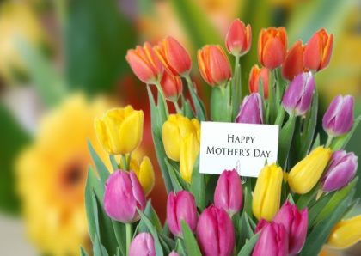  Descriptor:  -look at the pictures  -guess the name of holidays  - give your opinion clearly |  | https://yandex.kz/search/?text=music%20for%20mother%27s%20day&lr=221&clid=2328149-596&win=386#/videowiz?filmId=2121598809851893025  https://yandex.kz/video/search?filmId=2553977741399732741&text=songs%20for%20victory%20day&noreask=1&path=wizard
Middle  5 min  3 min  3 min  2 min  5 min  8 min  3 min  3 min  8 min | New lesson  Probbing question  What is a holiday?  What holidays do you celebrate?  Why do we celebrate national holidays?  What holiday do you really look forward to?  Do you like holidays?  How many holidays have you at school?  Is it better to stay at home on holidays or go somewhere?  Learners should answer the questions and give their opinions.  Teacher elicits different holidays to make a mind map.  Independence day  Victory day  Day of Astana  Halloween  Christmas  Nauryz  Women’s day  Easter  New Year  St.Valentine's Day  Task 1 The method "Snowball".Each group revise the names of Holidays then they throw ball to each other by asking what holiday is celebrated on these dates.  1 It is celebrated on December 25th:____________  2 It is celebrated on February 14th:_____________  3 It is celebrated on March 8th:_______________  4 It is celebrated on January 1st:__________  5 It is celebrated on the 22nd of March___________  6 It is celebrated on the 9th of may:_____________  7 It is celebrated on the 16th and 17th of December____________  8 It is celebrated on July 6th:________________  9 It is celebrated on October 31st:______________  10 It is celebrated on April 21st________________  Descriptor:  -work with group  -find the names of holiday  -pronounce the word correctly  Differentation: by peer support.  Task 2 Poster.Each group are given key words belong to Holidays.They should guess and make a poster of Holiday celebrations.  The 1st group  Socks,fireworks,roast turkey,bells,candles,cards,cold,chimney,gifts,lights,pie,jolly,snow.  The 2nd group  Snowdrops,altybahan,horse,games,yurt,grass,national,best wishes,  Baursaks  Descriptor: A learner  • make poster and describe it.  • speak clearly in English.  AFL --, Oral feedback’’  Differentiation by ability: More able Ss used given words in the text to describe the holidays.  Task 3 “Who is the best? ”  Individual work.Answer the questions.  1 How do you celebrate your birthday?  2 How do you celebrate Christmas holiday?  3 What holiday do you like and how do you celebrate it?  4 What do you do on Independence Day?  5 What is your favourite holiday?Talk about it.  6 How do you usually celebrate St.Valentine's Day?  Descriptor: A learner  - Listen attentively and respond the right answers;  - Use more topic vocabulary  - Give own opinion clearly..  Differentiation  by ability: More able Ss correct the false sentences  AFL:"Oral feedback".  Task 4."Advertisment". Group work. Students should choose one international holiday and decide how to celebrate it.They should make note under the headings and then use their notes to write an advert. Each group have to present their ideas to the class.  Suggested Answer Key  Day: Teacher's Day,1st October  Place: School  Time: 9 am – 3 pm  Decorations: pictures,flowers,posters of best wishes  Events: concert,poems, pupil'performaces for teachers,organizing different parties.  Place:  Time:  Decorations:  Events:  Teacher assess  Descriptor: A learner  • write correctly  • choose right words according to the topic.  AFl: Group assessment  Differentiation by ability –More able learners explain the meaning of the questions to less able learners.  Afl: Peer-assessment |  | https://rgsu.net/about/campus/infrastruct/obshepit/  https://britishcinematographer.co.uk/problems-modern-day-cinema-rise-drones/  https://sweetwaterstudios.com/studio-a/  https://www.aeronewstv.com/en/lifestyle/in-your-opinion/2954-how-many-commercial-airports-are-there-in-the-world.html
End  3 min | Reflection “Five fingers”  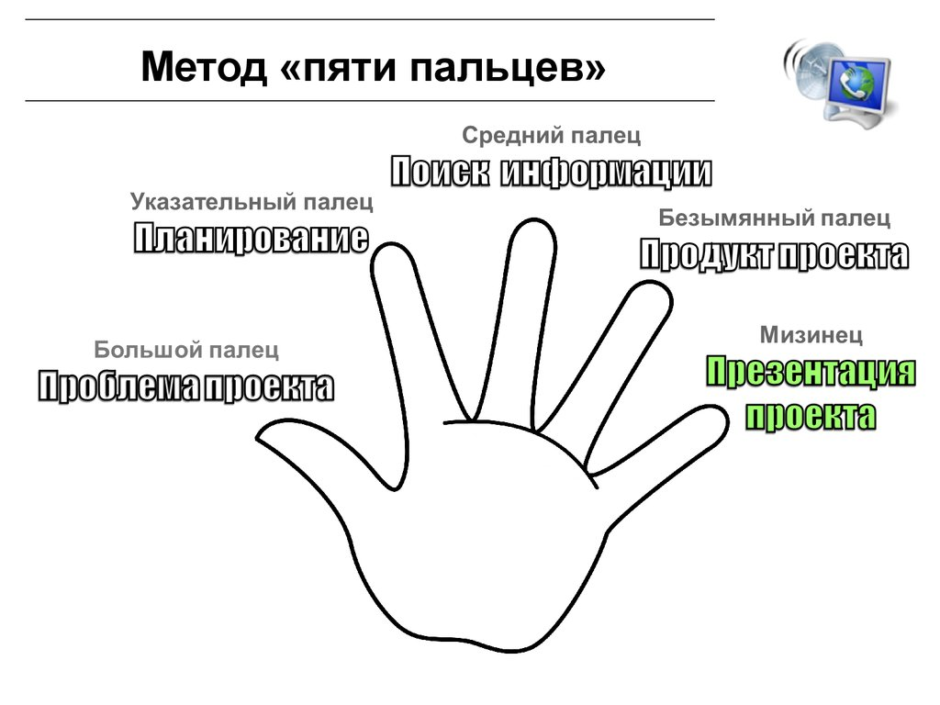  Which task did you like the most?  What was easy for you?  What was difficult for you?  Show on your fingers your opinion about the lesson  1-the lesson was difficult  2-you liked the most  3-your mood glad, sad, bad  4-Activities you have done  5-I learnt today  Reflection through “Five fingers”  1 finger – difficulties during the lesson  2 finger – what do you like during the lesson  3 finger – your mood  4 finger – what do you do today?  5 finger – what do you learn today?  Learners draw the shape of their hands and write on each finger.  Hometask:Write an essay about your favourite holiday.

